

MSD SOP for Azure Site Recovery (Modernized) for On Premises VMware

Overview & Goals.

The “Purpose” of a SOP is to provide detailed instructions on how to setup Azure Site Recovery replication appliance – Modernized for ON premises (VMware) machines
Prerequisite for Appliance Server
- Window Server 2019.
- Data disk with 600GB free disk.
- Antivirus should be uninstalled before proceeding.

Go to Recovery Services Vault > Getting Started. In VMware machines to Azure, select Prepare Infrastructure and proceed with the sections detailed below:

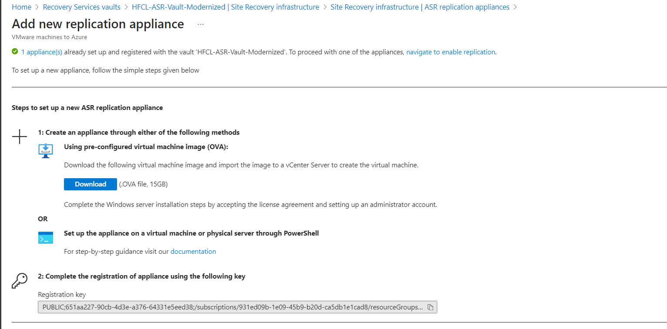

Download the step up from below link-
1,https://aka.ms/V2ARcmApplianceCreationPowershellZip
2.After successfully copying the zip folder, unzip and extract the components of the folder.
3.Go to the path in which the folder is extracted to and execute the following PowerShell script as an administrator:
DRInstaller.ps1

After installation, below url will open, fill up the requirement.
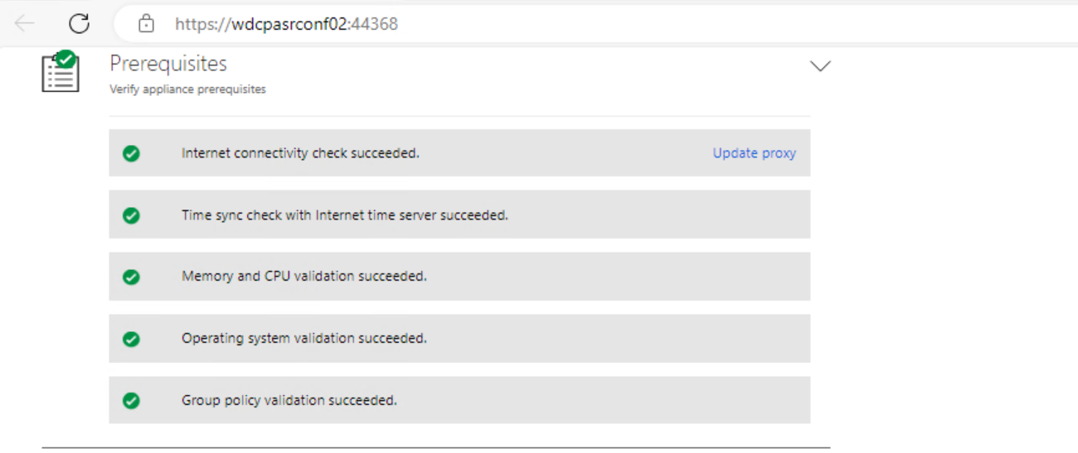

Add vCenter details and credential
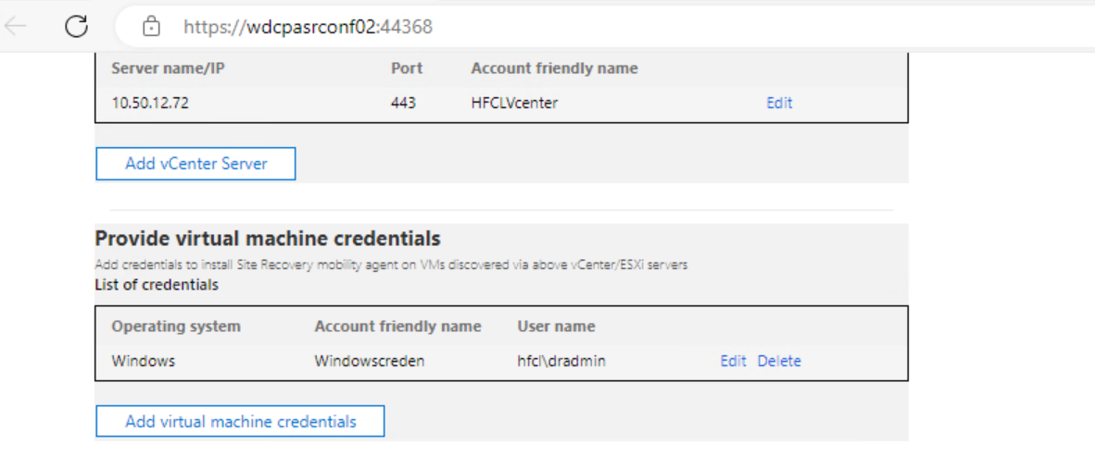

After installation the appliance server will be visible in Azur portal.
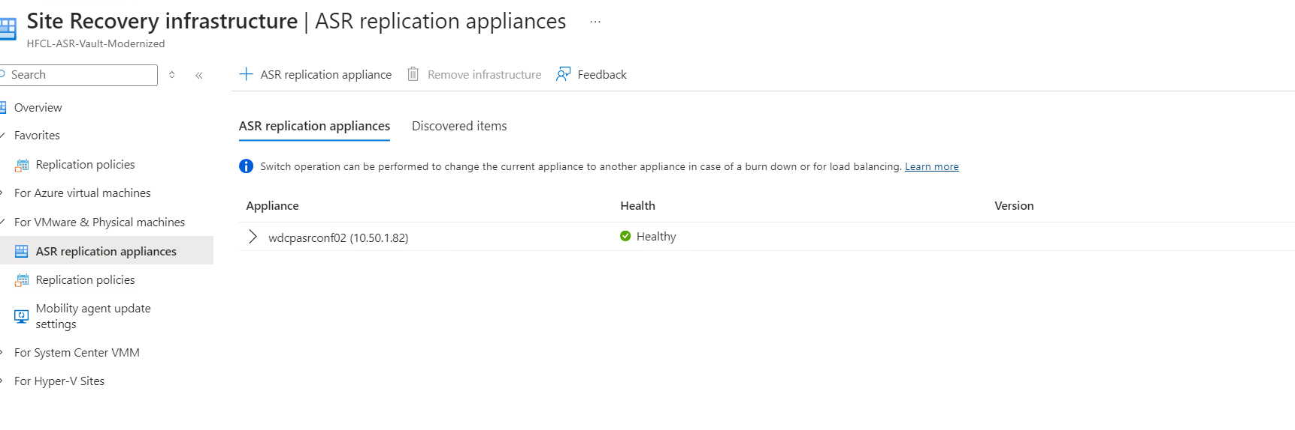

Once the appliance server is ready, disable the replication from OLD ASR
For Windows Server

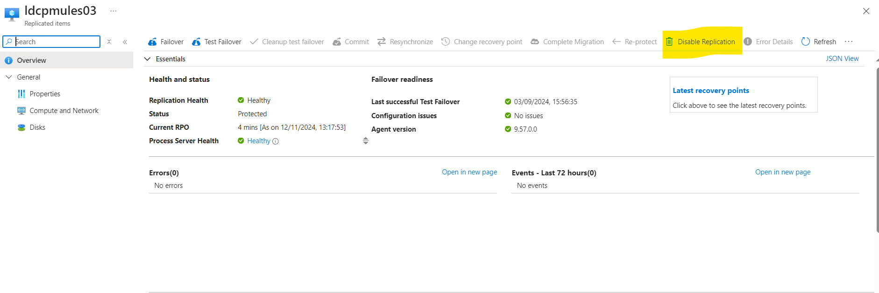
Remove the agent from Source Server and reboot it.
After rebooting install the agent, Location mentioned in below snapshot(10.50.1.82)
About the Mobility service for disaster recovery of VMware VMs and physical servers with Azure Site Recovery - Azure Site Recovery | Microsoft Learn

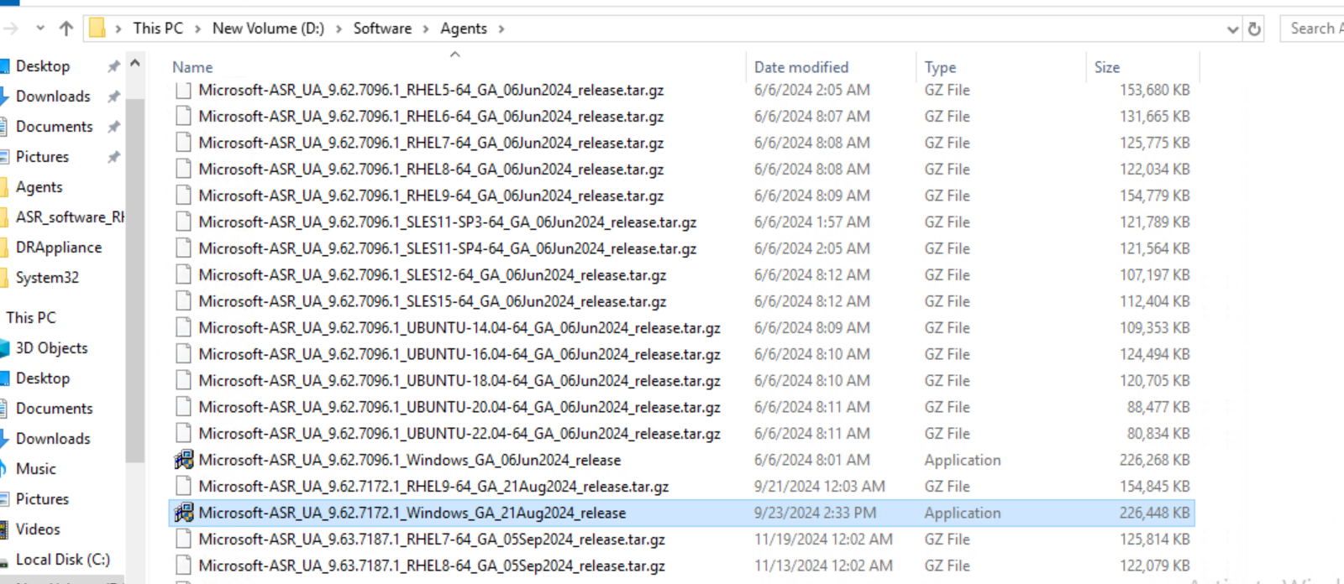

Double click and the installation will start and location will be C:\Program Files(x86)\Microsoft Azure Site Recovery.
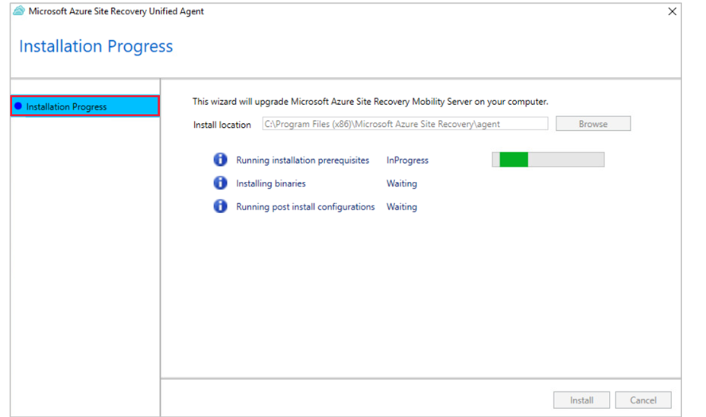

Once the installation is done, you will need to register the source machine with the appliance of your choice. To do so, copy the string present in the field Machine Detail ‘’e.g’eyJCaW9zSWQiOiIzNDBjMjk0Mi00Y2Q4LWE4YTQtM2JkMC1iZTg2ZDUxN2MwN2YiLAoiRnFkbiI6IndkY3BmdG5hcHAwMy5IRVJPRklOQ09SUC5DT00iCn0=’
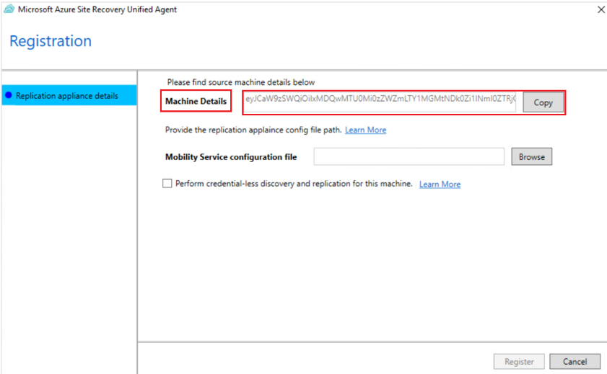

Paste the same in Source Input.

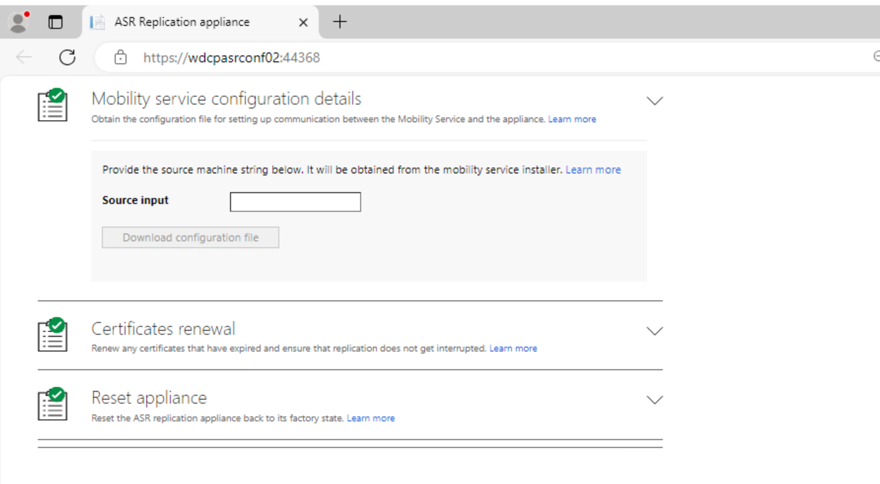
Then Download the configuration file
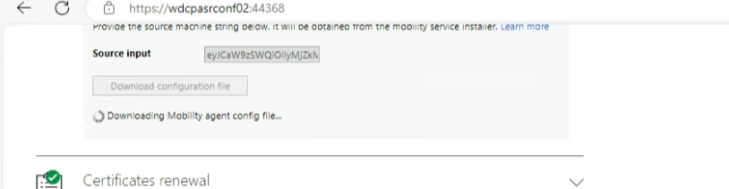

And upload the same in Source Server.

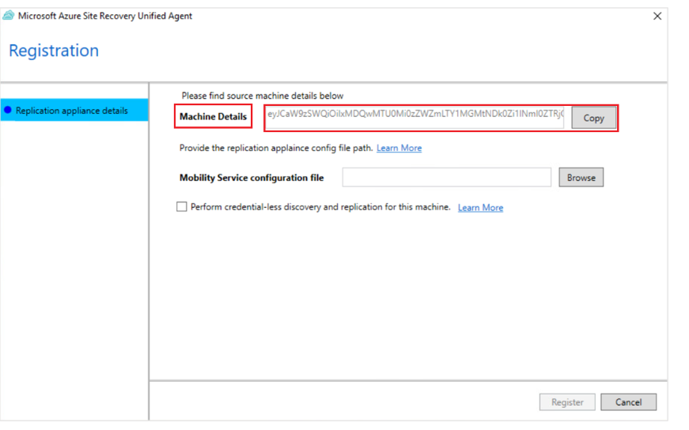
Open the Azure Portal and go to ASR.
About the Mobility service for disaster recovery of VMware VMs and physical servers with Azure Site Recovery - Azure Site Recovery | Microsoft Learn

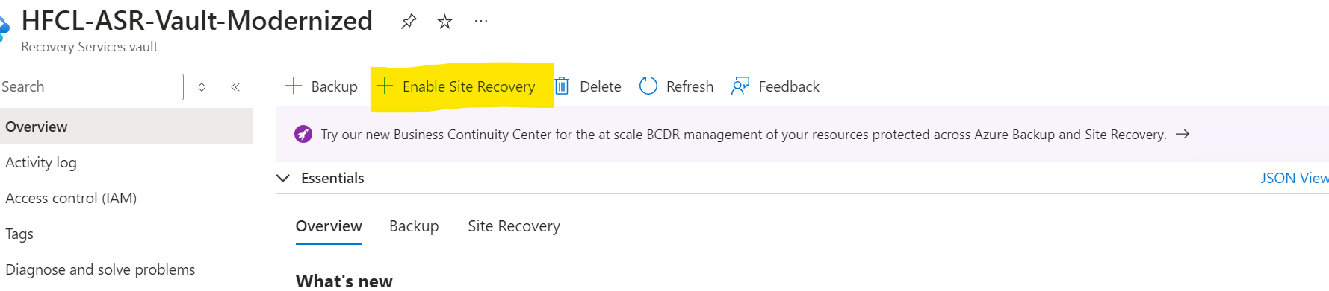

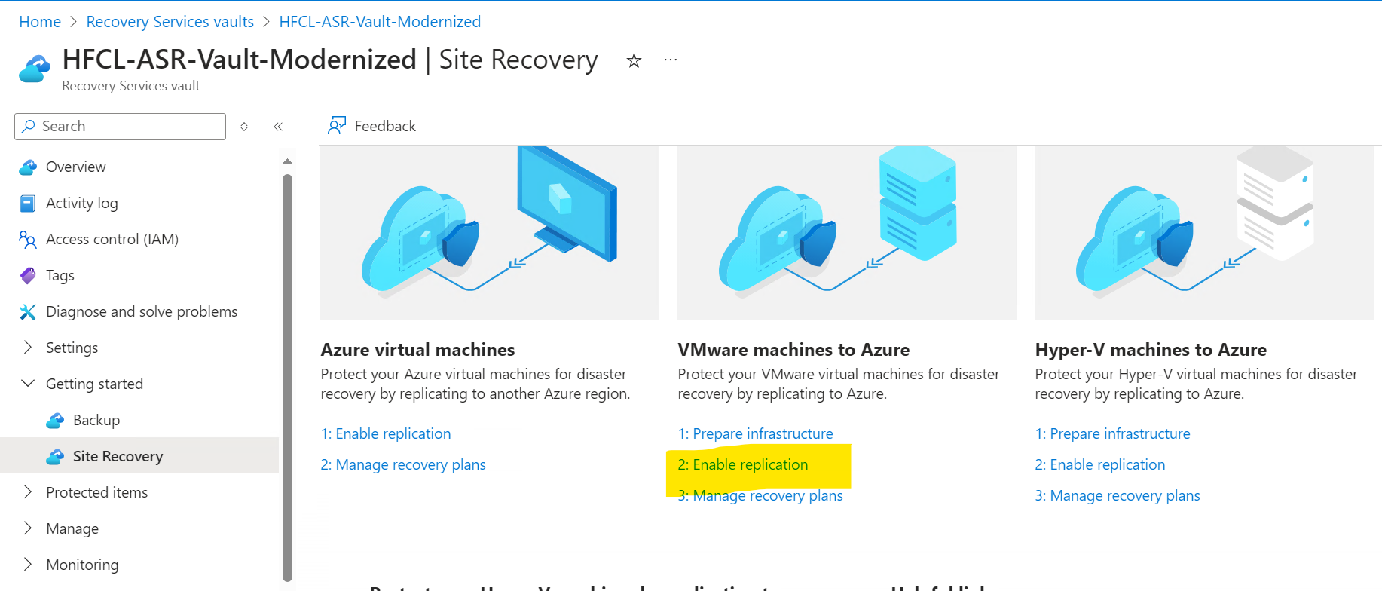
Search the VM which needs to be added in Replication.

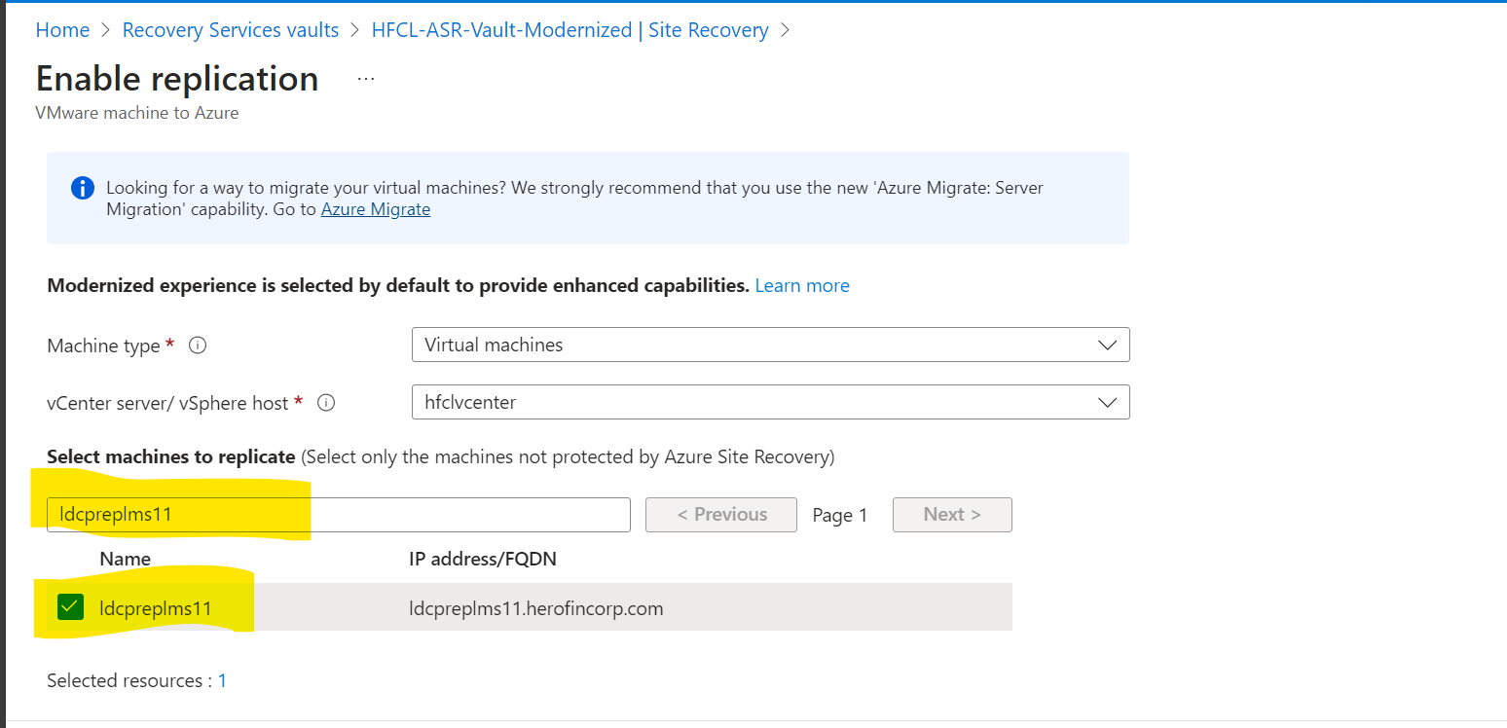

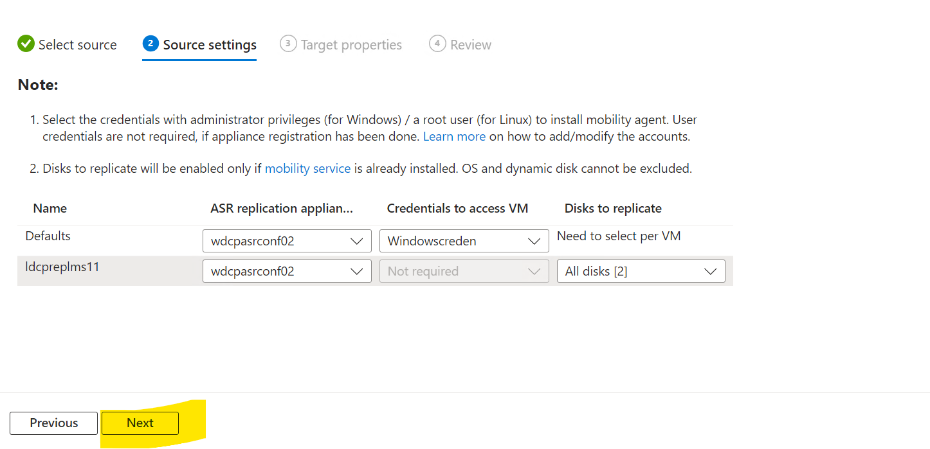
Add the following information.
- VNET
- Storage
- Replication Policy

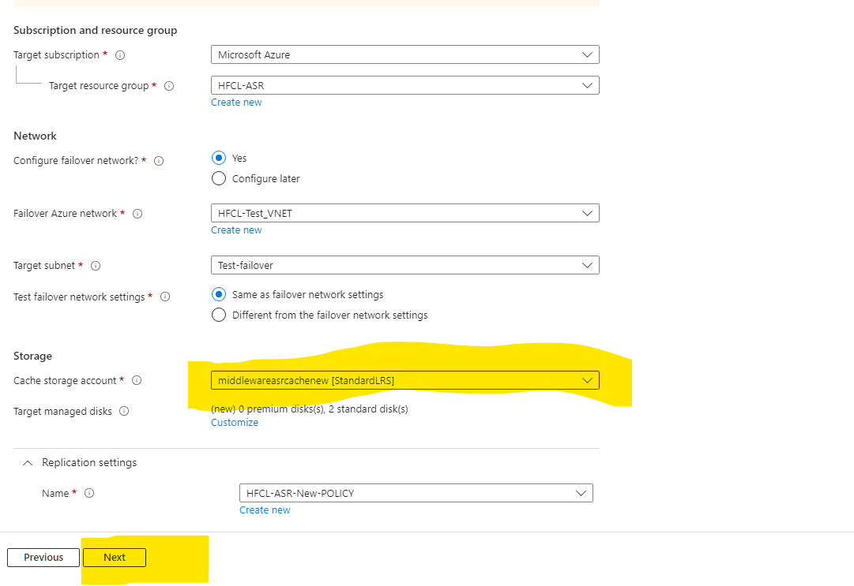
Enable Replication.
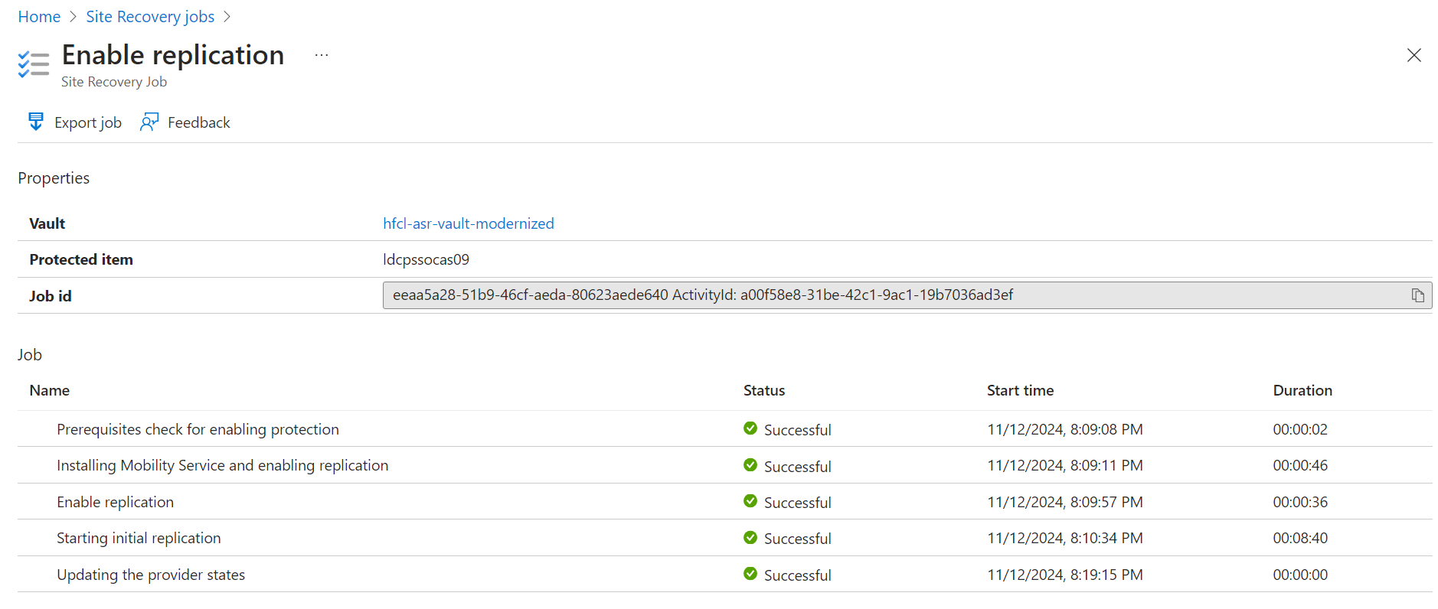

For Linux , Configuration remains the same in Appliance server and Azure Portal.
For agent removal and configuration in Linux follow the below article.

About the Mobility service for disaster recovery of VMware VMs and physical servers with Azure Site Recovery - Azure Site Recovery | Microsoft Learn

